**Documenttation of EProject**

**Group Members**

**Nashrah Urooj Student1510839**

**Rana Mubashir Student1511488**

**Shema Dildar Student1510745**

**Arshad Hussain Student1510762**

**Ali Huzaifa Student1511970**

Submitted To :

Project Instructor : Mrs. Kaneez Fatima

Curriculum Code : OV-ACCP-PRIME (7062)

MAIN CODING (HTML)

SCREENSHOTS

**NAVBAR:**

**Html:**

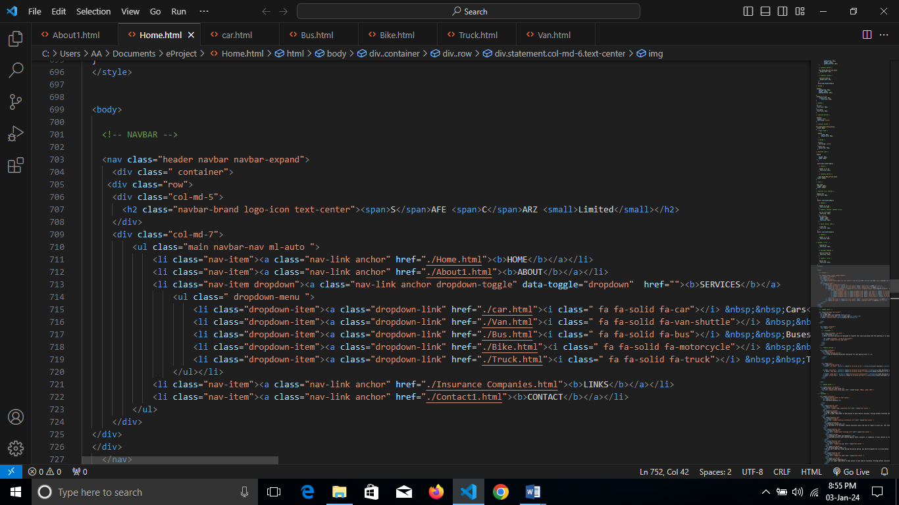

**Css:**

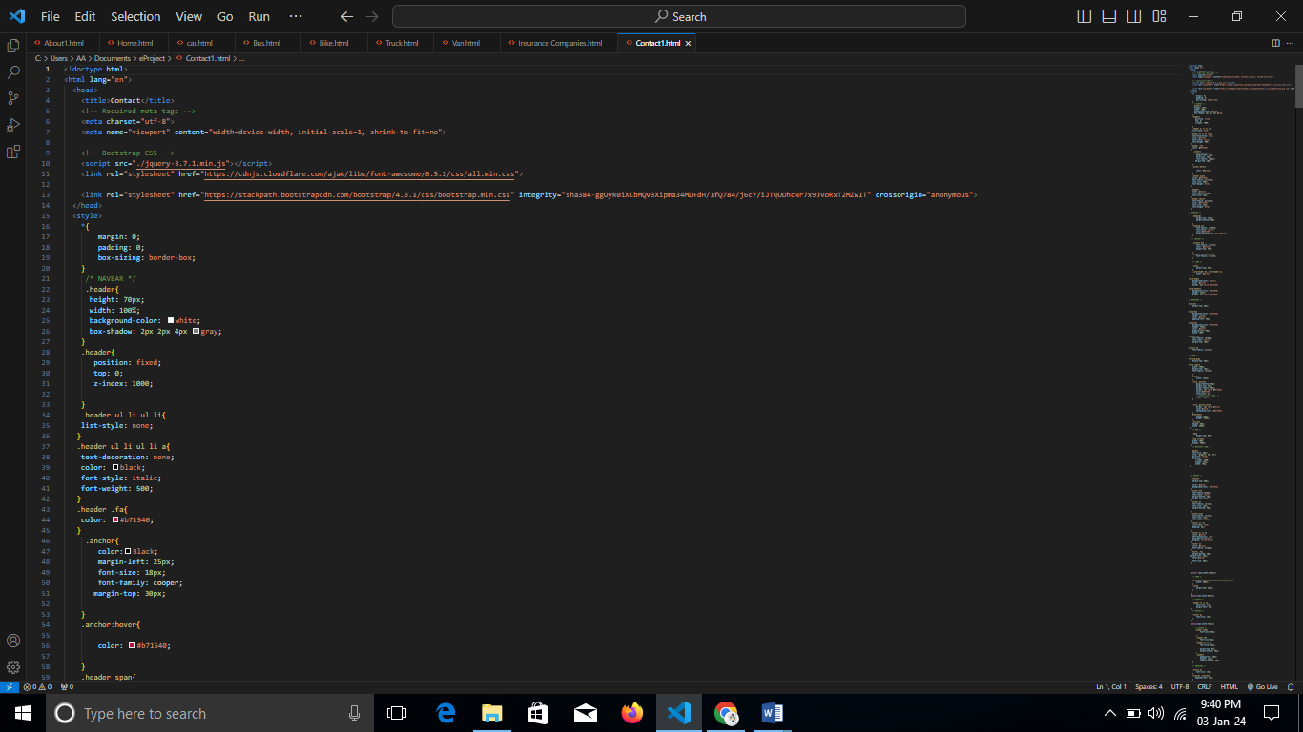

**Output:**

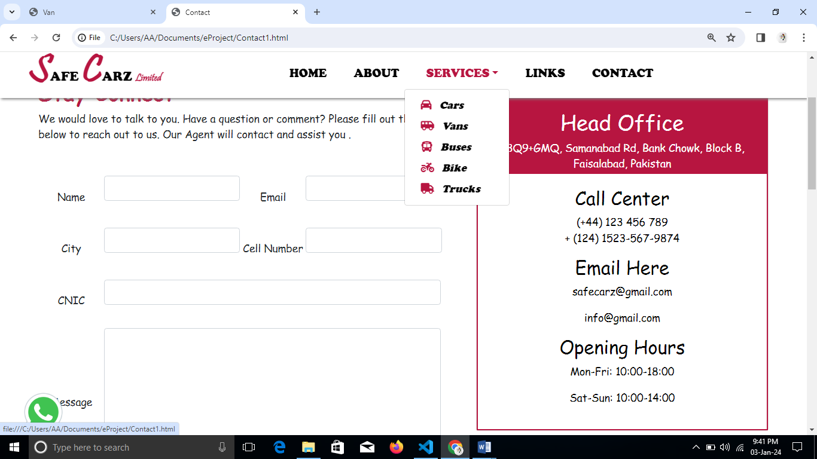

**Footer:**

**Html:**

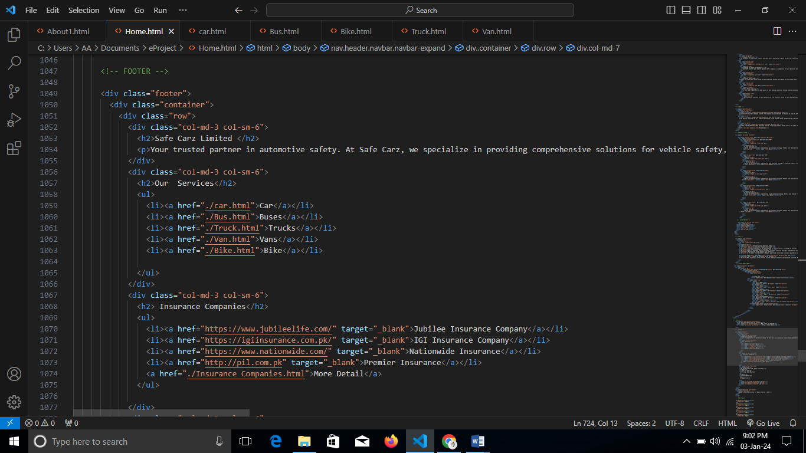

**Css:**

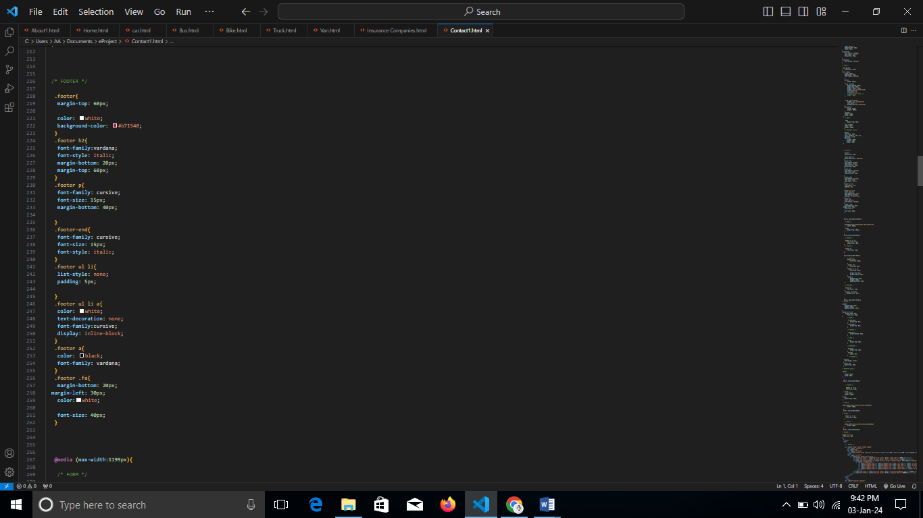

**Output:**

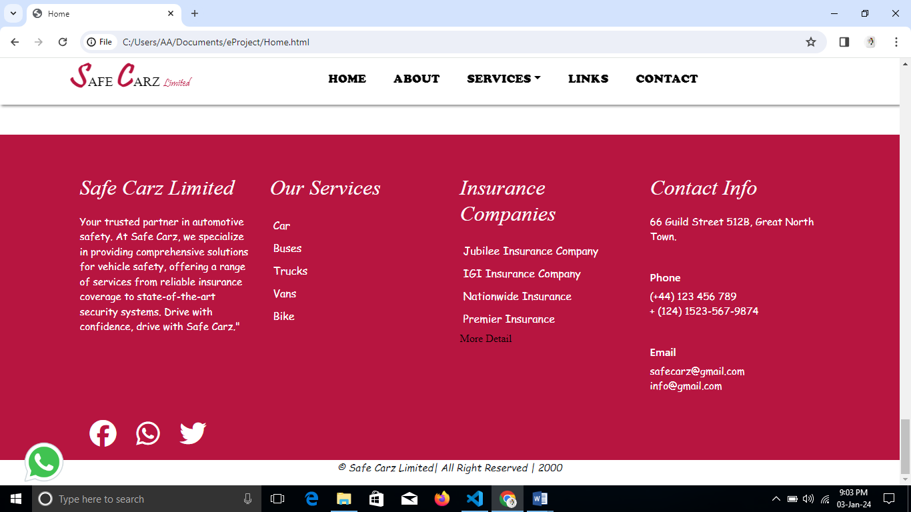

**HOME**

**Html:**

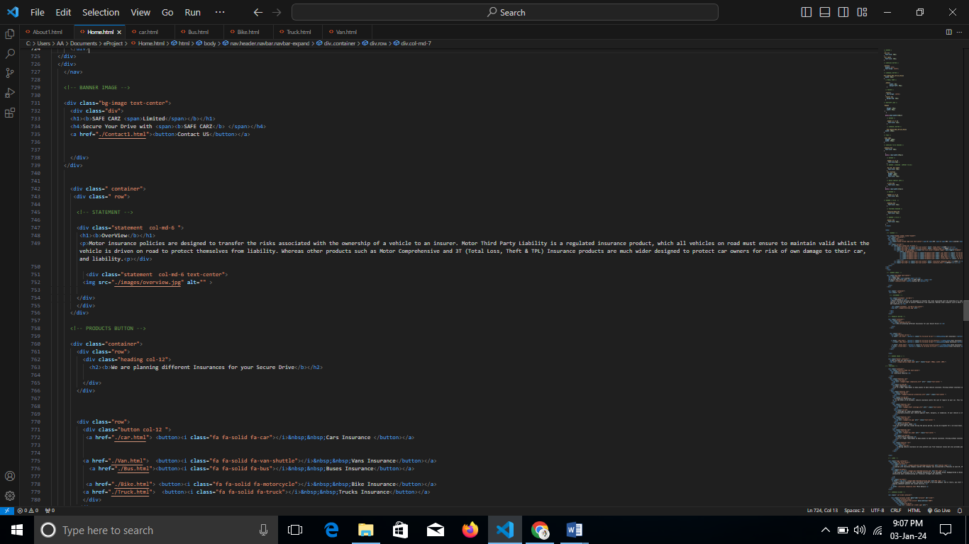

**0utput:**

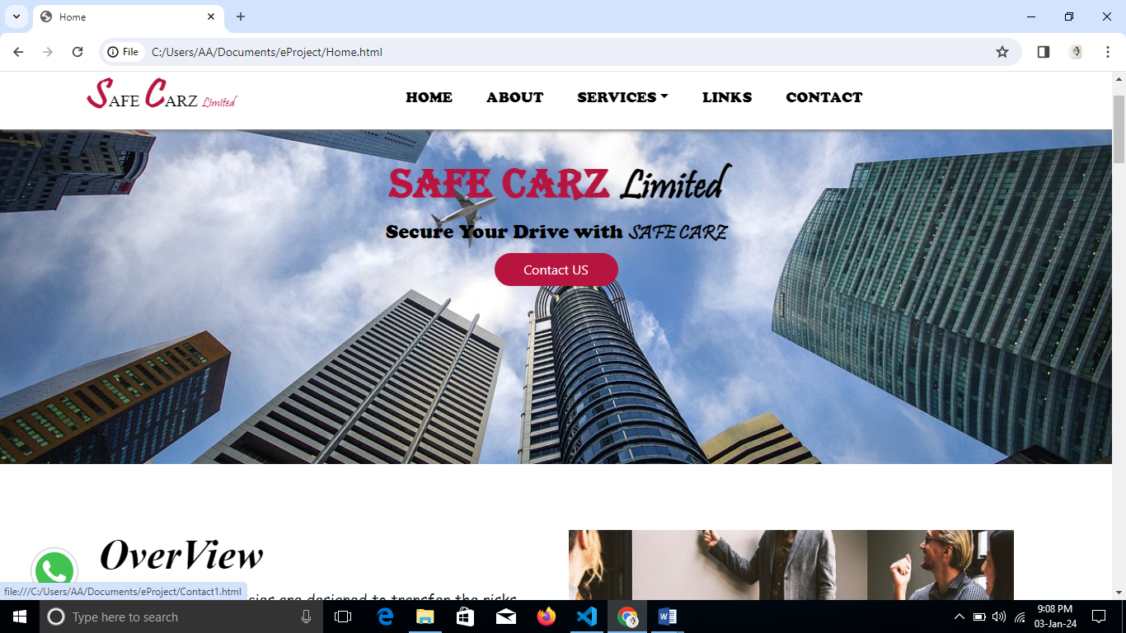

**ABOUT**

**Html:**

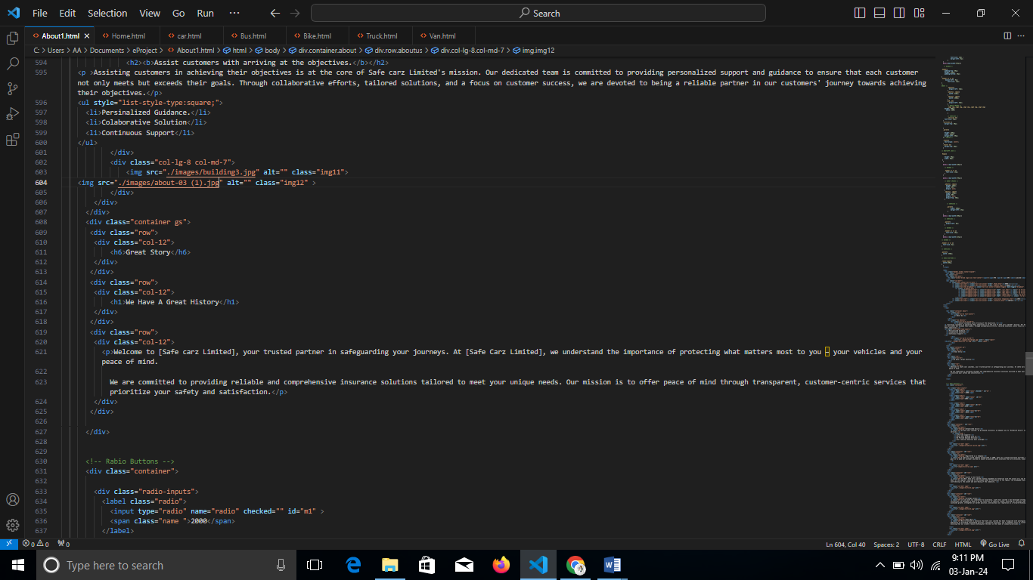

**Css:**

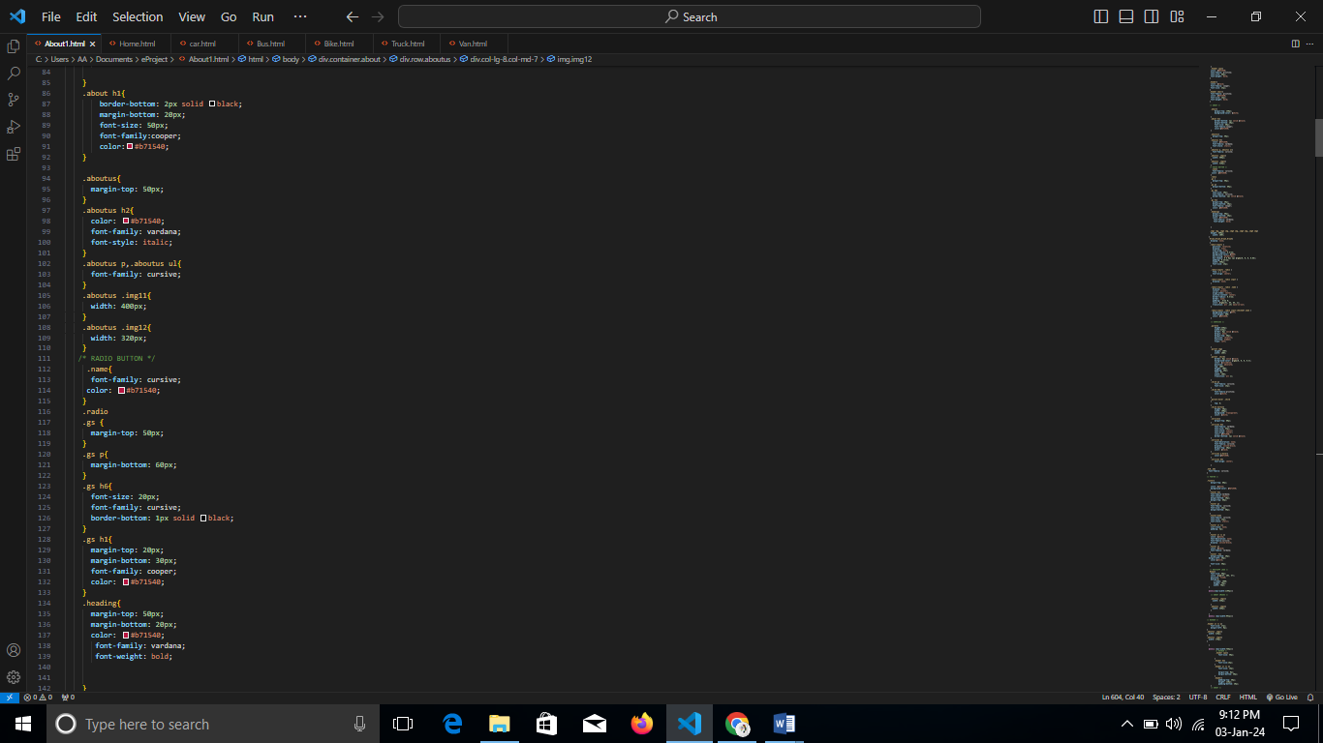

**JQuery:**

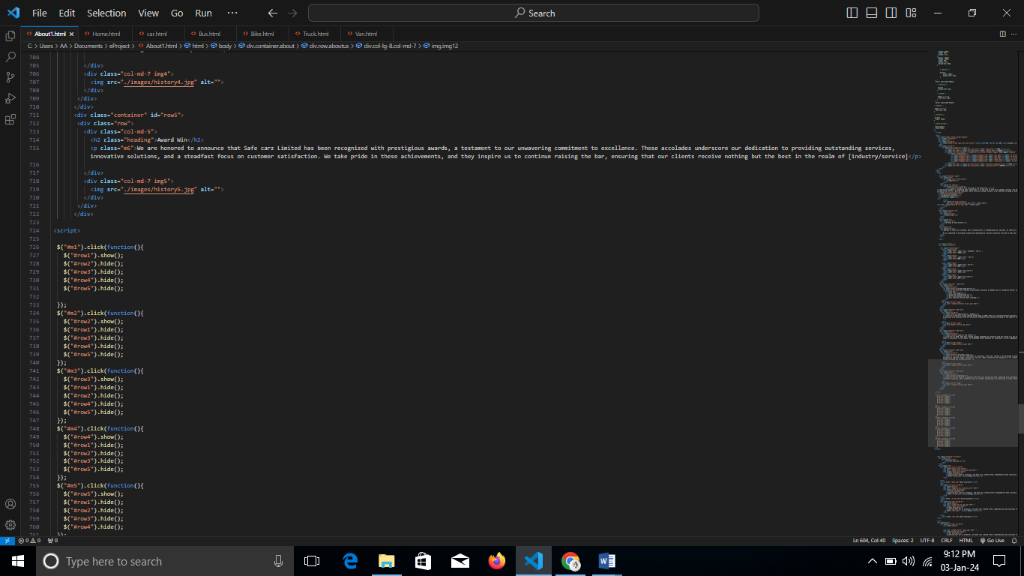

**Output:**

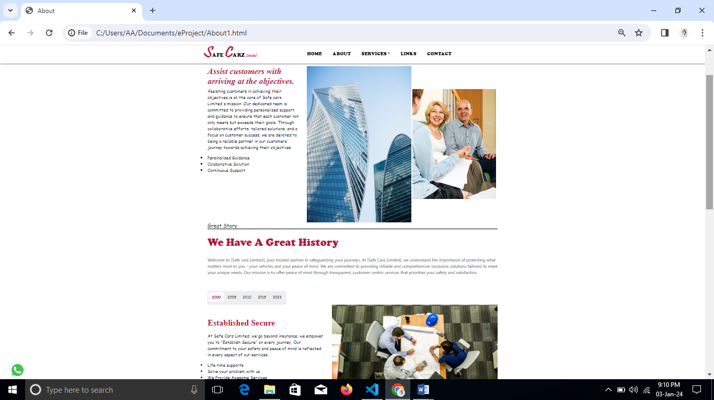

**SERVICES**

**Html:**  
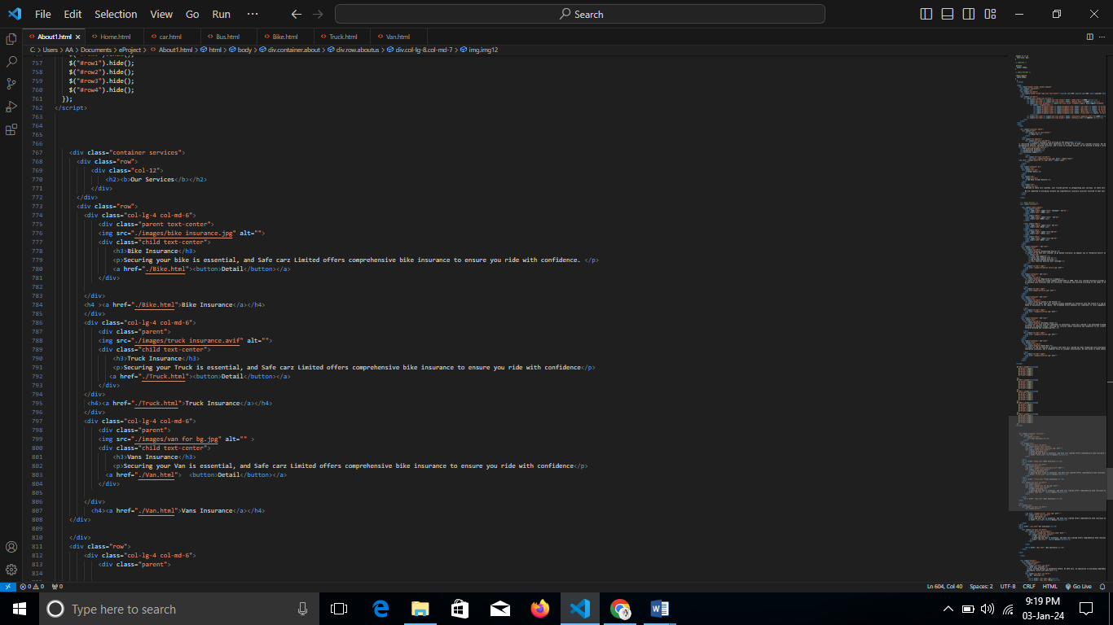

**Css:**

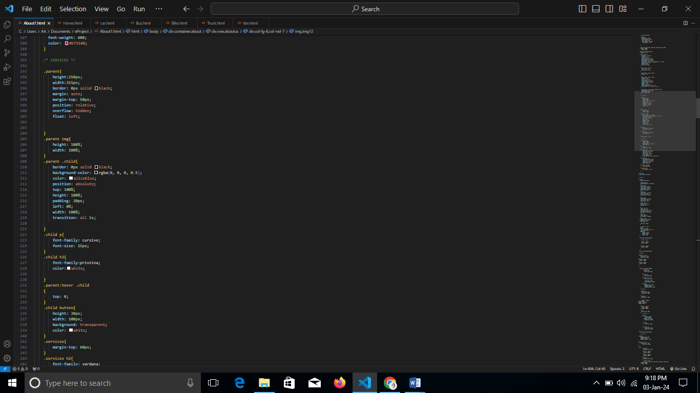

**Output:**

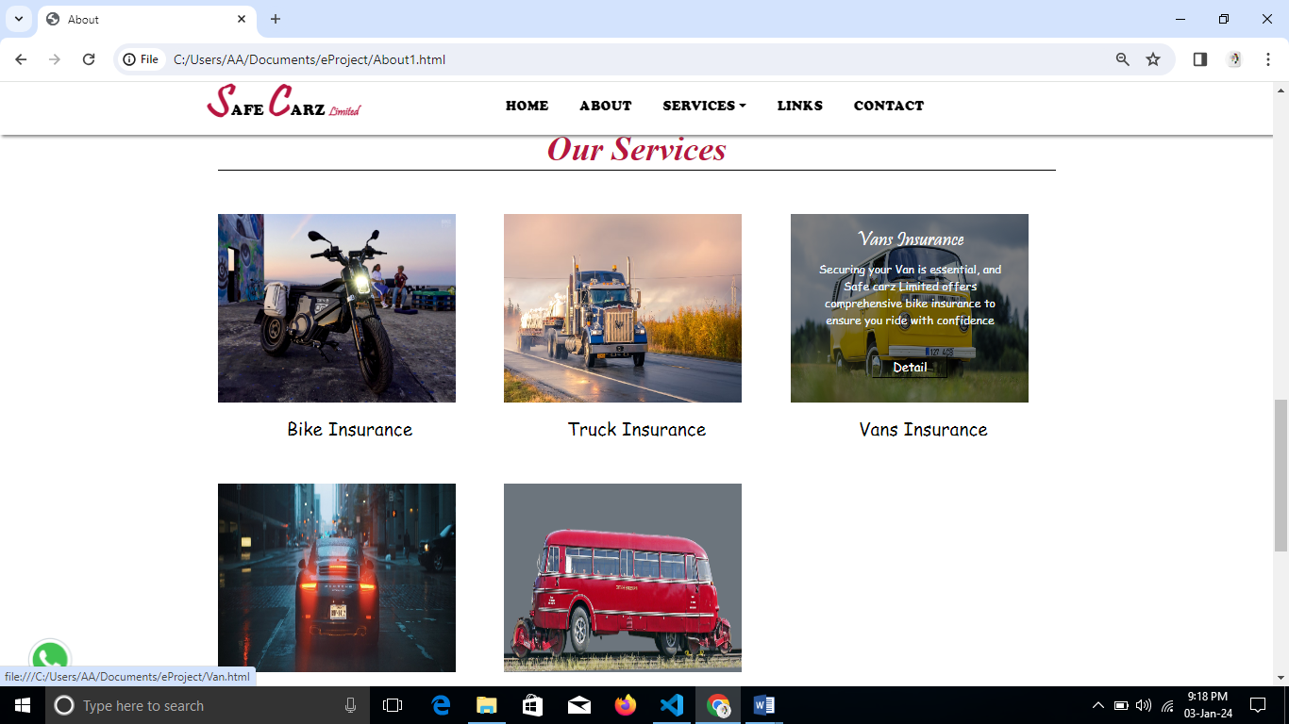

**INDIVIUAL SERVICE PAGE:**

**VAN INSURANCE:**

**HTML:**  
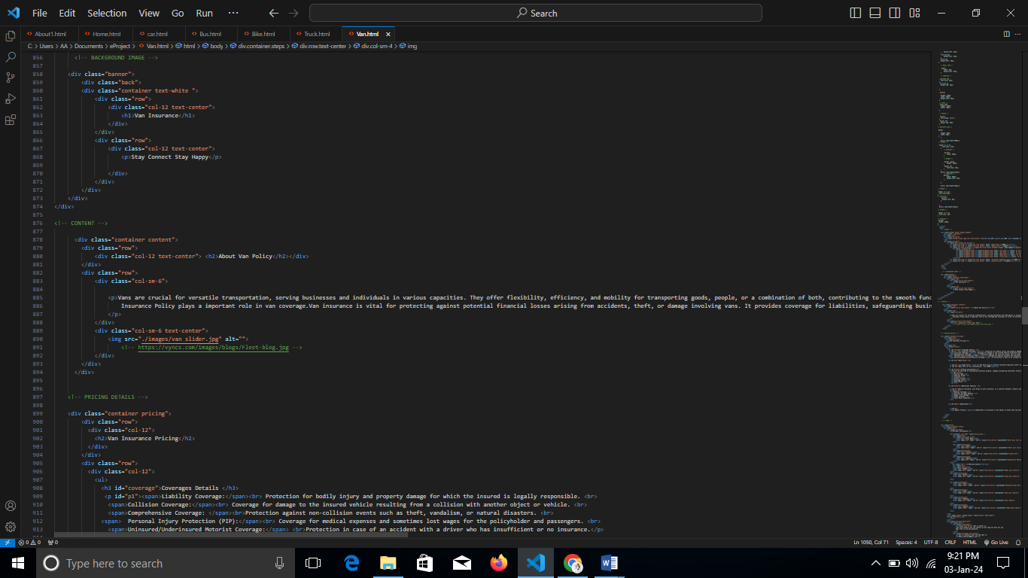

**Css:**

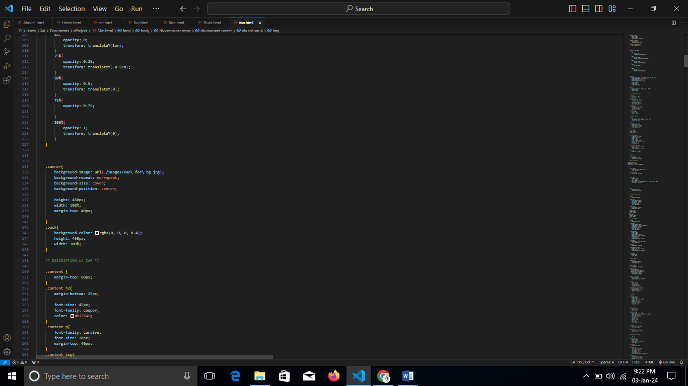

**Output:**

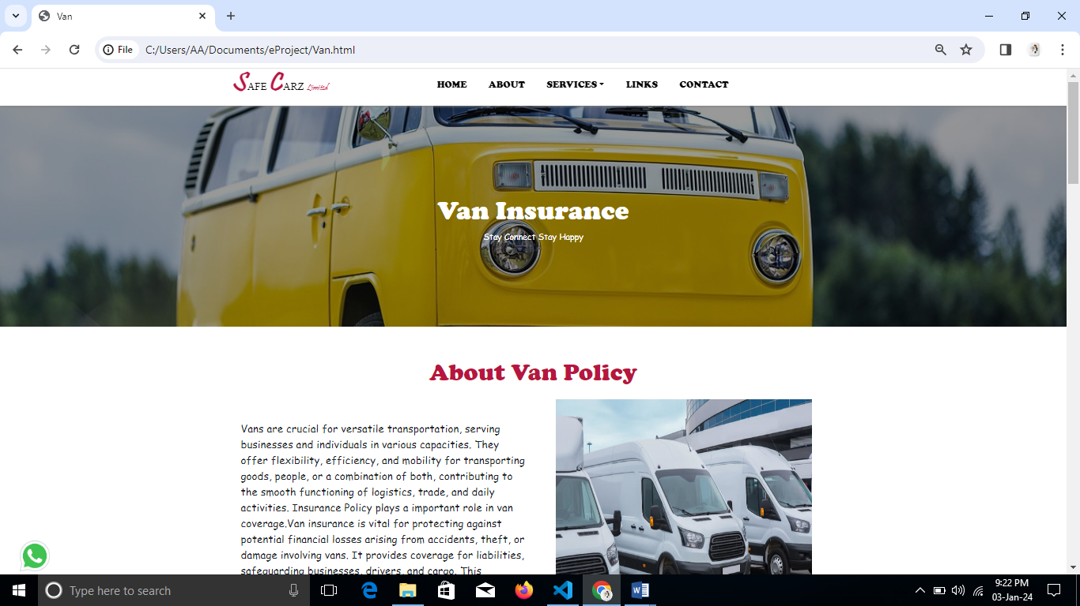

**POLICY FORM:**

**Html:**

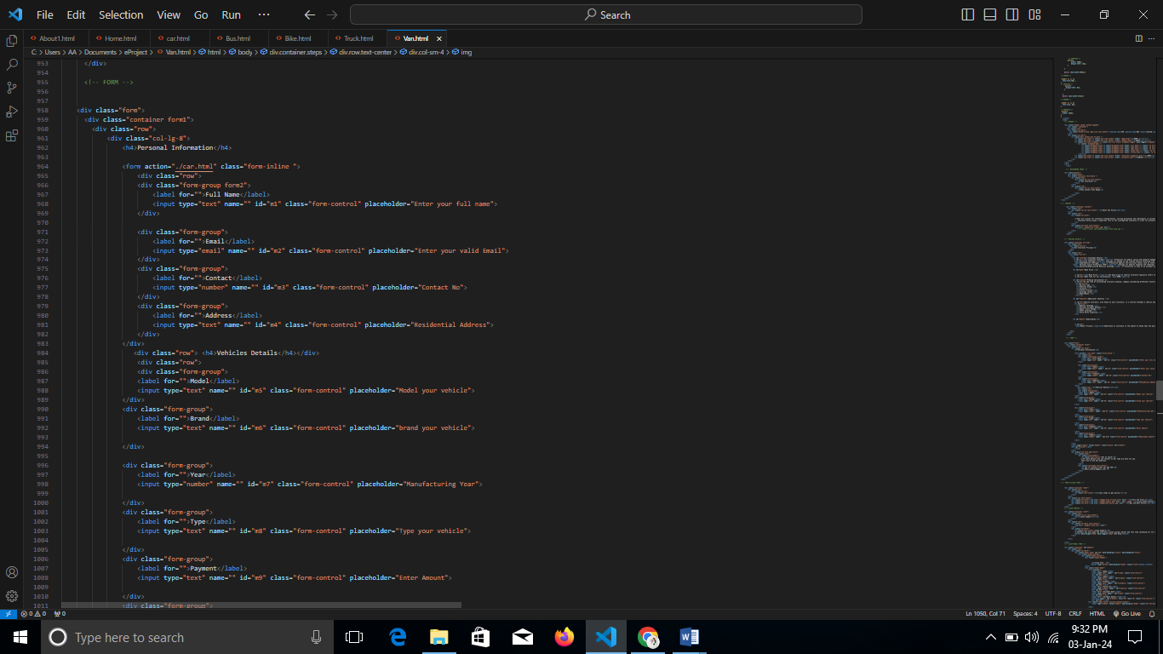

**Css:**

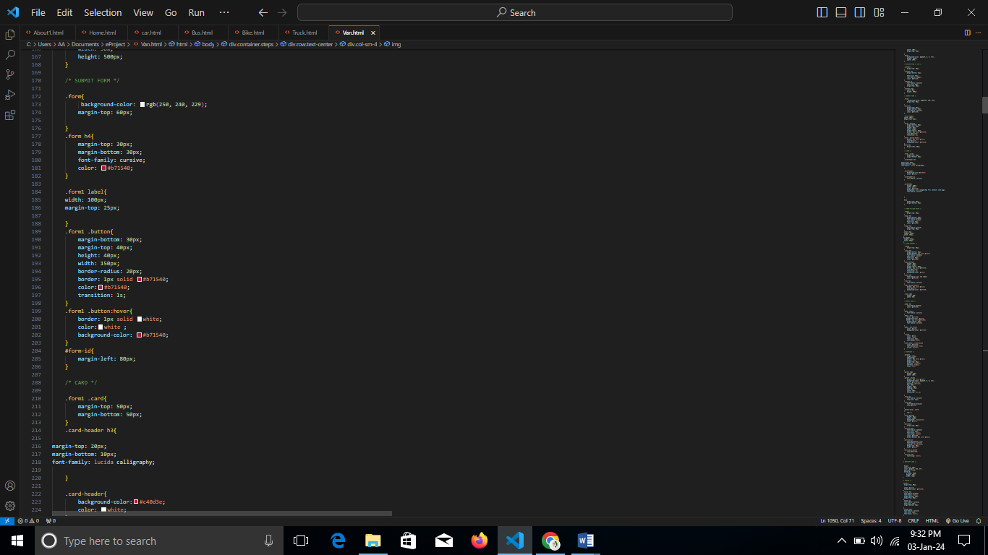

**Jquery:**

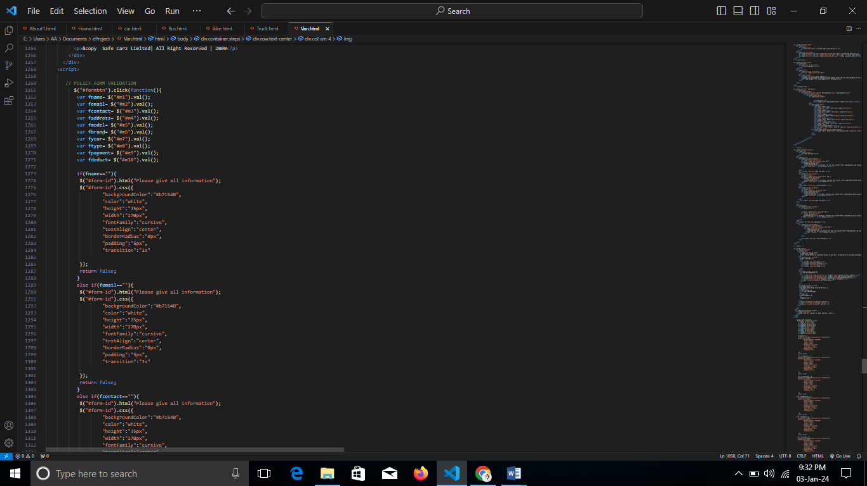

**Output:**

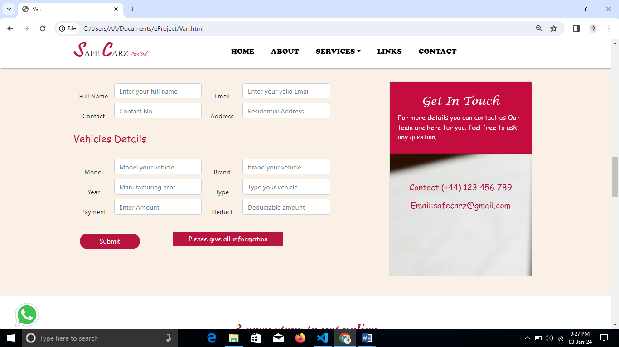

**CLAIM FORM:**  
**Html:**  
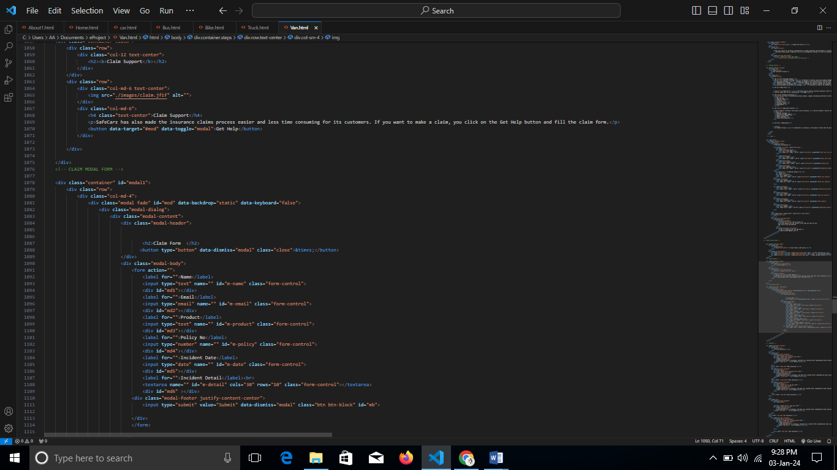

**Css:**

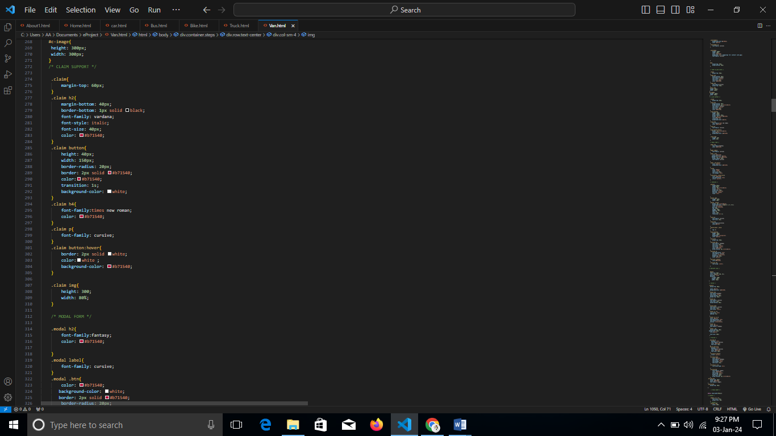

**Jquery:**  
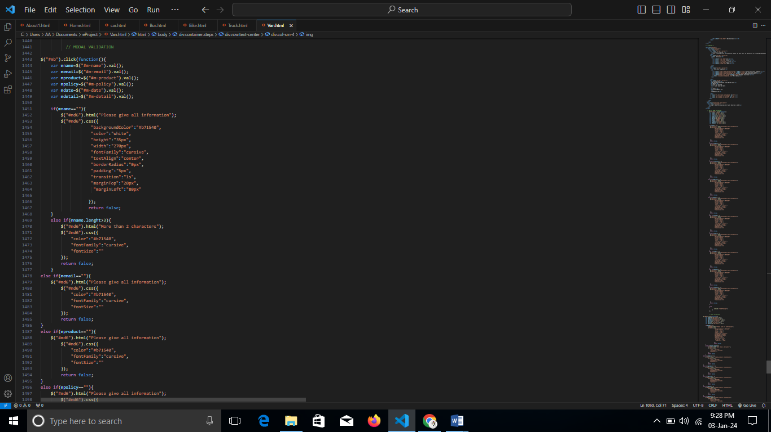

**Output:**

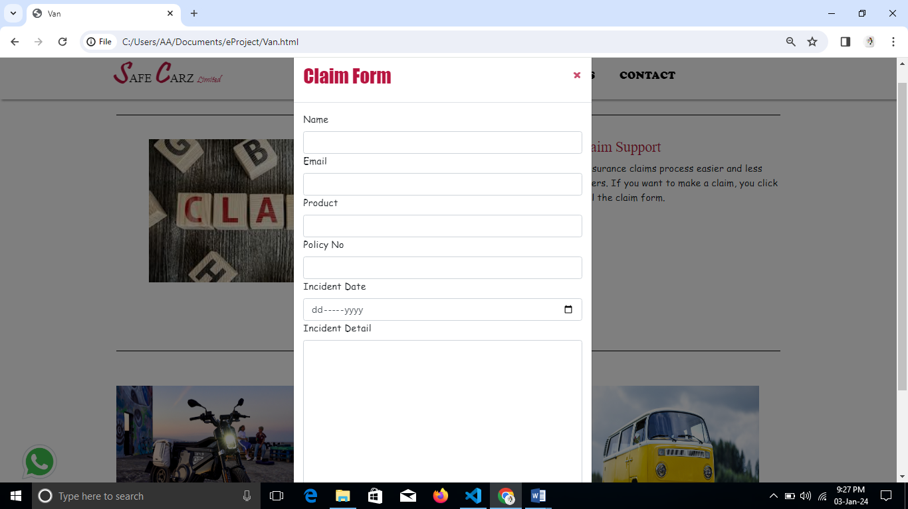

**OTHER COMPANIES LINKS**

**Html:**

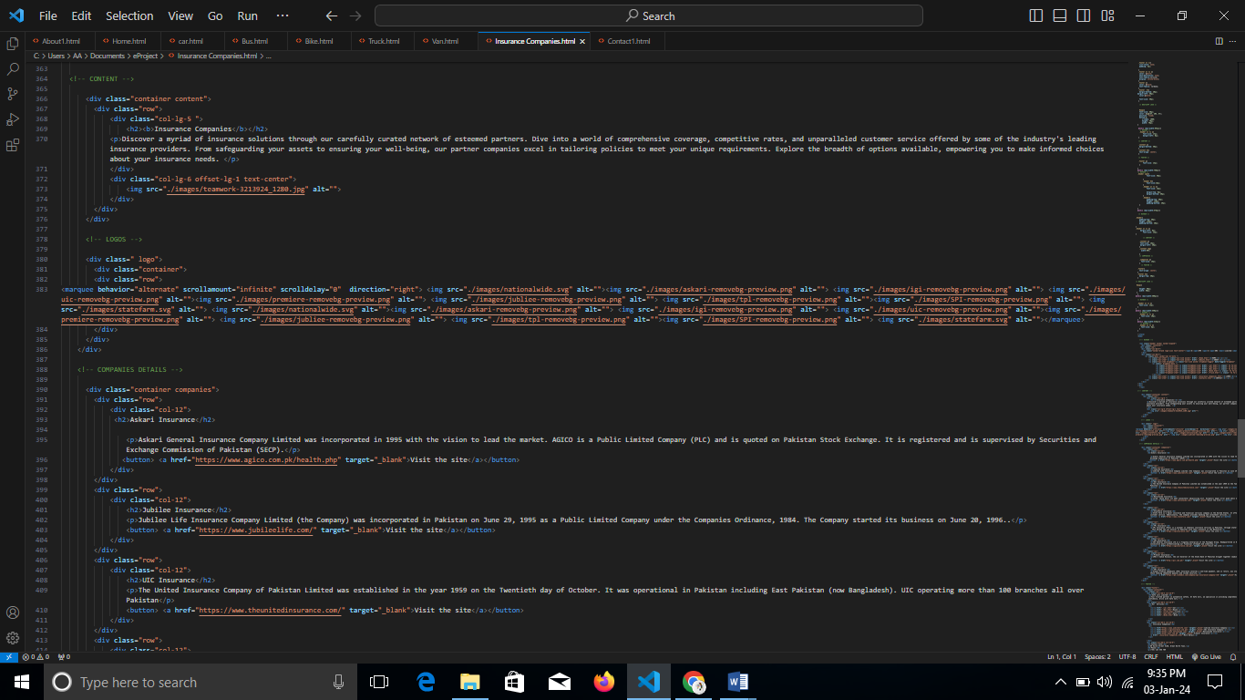

**Css:**

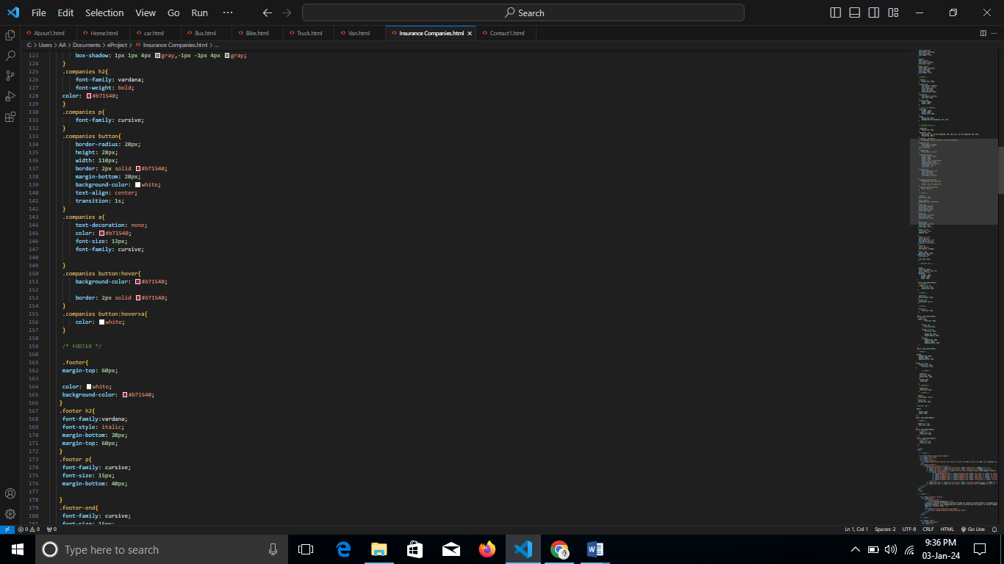

**Output:**

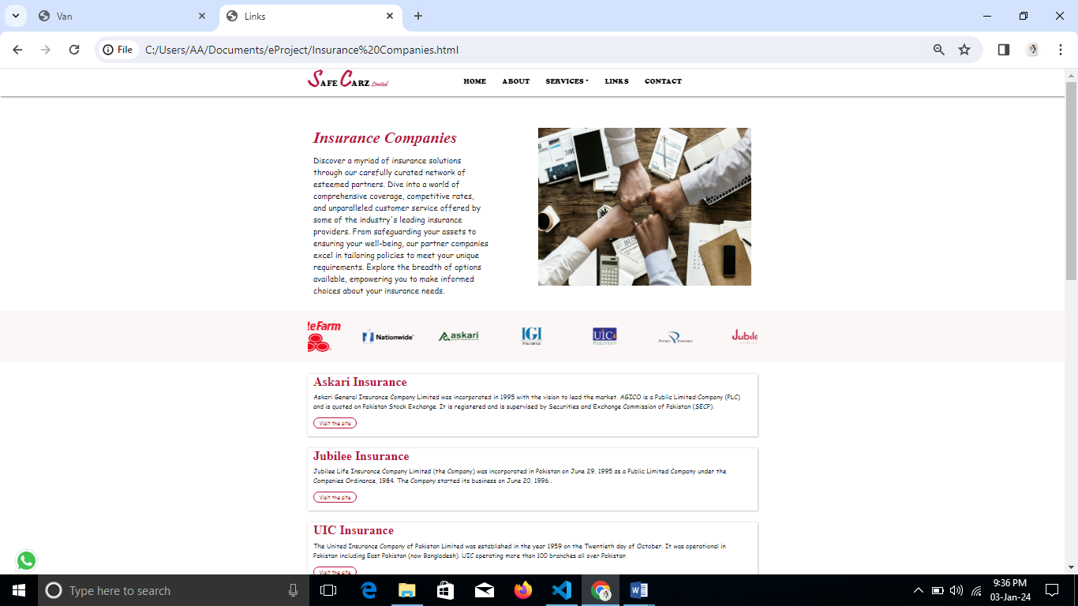

**CONTACT**

**Html:**

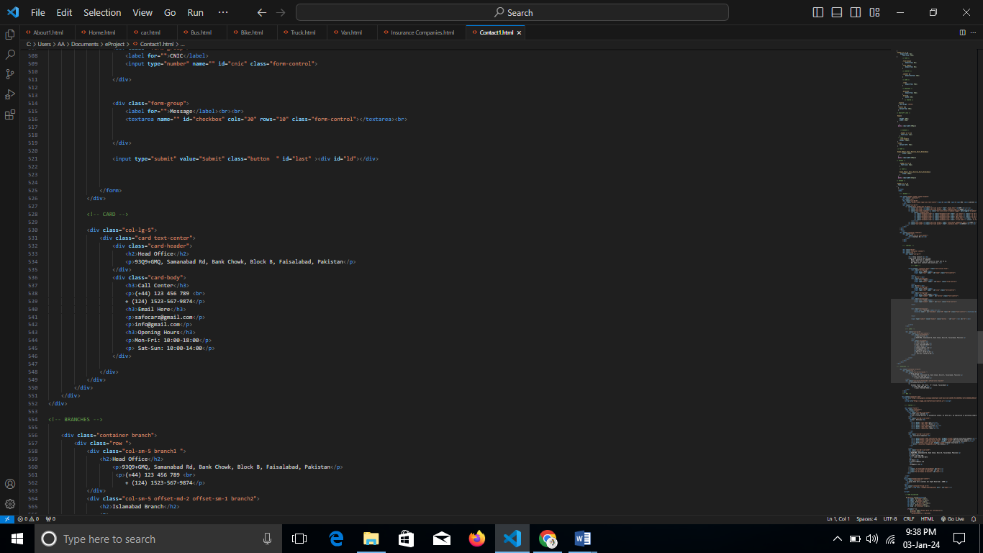

**Css:**

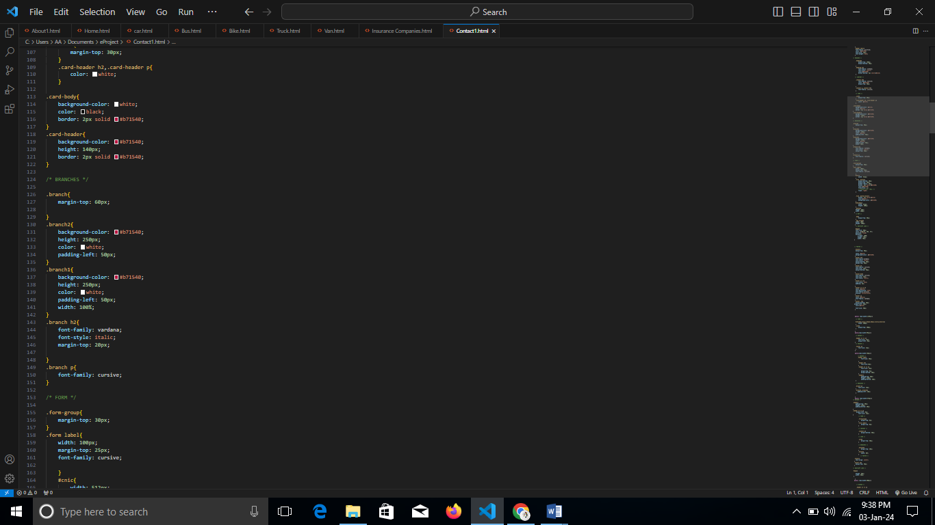

**Output:**

